2.1 Introduction

This chapter is dedicated to scrutinizing literatures which investigate similar problem domains in the hope of identifying and analyzing basic concepts embedded within that body of research. Hence, first it is discussed about the motor vehicle insurance niche in the insurance field. It is followed by a discussion on smartphone technologies, usage of smartphones in Sri Lanka and an overall discussion about the emerging web technologies in the technical world.

In the next section, the feasibility of mobile technologies to the insurance industry is examined through studying past researches conducted on the similar subject by various researchers.

2.2 Motor Vehicle Insurance Industry: An overview

Over past years, the use of automobiles have become more common with the increasing complexity of human lives. In Sir Lanka for any vehicle, it is must to have a motor vehicle insurance before using the vehicle. The growth in the automobiles usage in the country has led to the establishment of insurance companies and it has become a competitive market segment in the industry. In the Fitch ratings it is stated that “Intense pricing competition in the motor segment is likely to hold the combined ratios in non-life above 100%”. Due to fall in imports with increased customs duty and unfavorable exchange rate movements, growth in the motor sector has dropped to 16.49 % in 2012 (2011: 29.56%). Yet, the influence of the motor segment in non-life remained high at 63.64% and will remain the major GWP contributor in non-life (Fitch ratings, 2014).

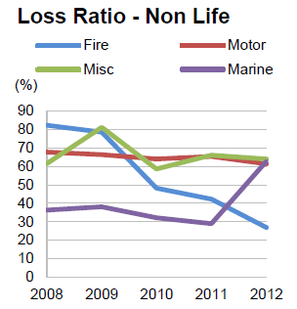

Figure 1.0: Loss Ratio - Non Life

Source: FitchRatings (2014)

Motor vehicle industry can be considered as an industry where there is a constant financial flow in-and-out with respect to a company. It is argued that cost savings and efficient process improvements in claims management business processes have a great impact on the key performance indicators of insurers(Baecker and Bereuter, 2010). The main reasons why cost savings are hard to achieve include the late involvement of insurers after car accidents, the limited integration of business partners such as repair shops, and improper information about the case circumstances (Kaeslin and El Hage 2008). As indicated by Capegemini 2013, Mobility has been acknowledged as a growing phenomenon in the insurance industry.

Since motor vehicle insurances is a fast growing area, it can be seen that with the help of latest technologies average claim life-cycle from set-up to close can be shortened as well as decrease the average costs per case since in contrast current motor vehicle insurance claiming procedure drags on for weeks to complete.

2.3 Smartphones in the Age of Mobility and Smart Devices: an Overview

A smartphone can be simply considered as a mobile phone with highly advanced features. Beal (n.d.) has described smartphones as a handheld device that integrates mobile phone capabilities with the more common features of a handheld computer or PDA. A smartphone is expected to have a more powerful CPU, more storage space, more RAM, greater connectivity options and larger screen. Smartphones are more powerful than regular cellular phones and PDAs in almost every aspects such as efficiency, reliability, user friendly and etc. A typical smartphone now a days generally has a high-resolution touch screen display, Wi-Fi connectivity, Web browsing capabilities, and the ability to accept sophisticated applications. The most popular mobile operating systems at the time being are Android, iOS and Windows Mobile.

The fine integration of these powerful hardware and software has paved a way to introduce sophisticated mobile devices with number of different services all in just one device. Those provided features along with the rapid developments in the internet technologies have amplified the usage of smartphone in the society. According to Gartner, a leading information technology research and advisory company, smartphones accounted for 53.6 percent of the overall mobile phone sales in 2013, which exceeded the annual sales of feature phones. Gartner revealed the global sales of smartphones to end users reached 968 million units during 2013, which is an increase of 42.3 percentage points from 2012's figure of 680 million.

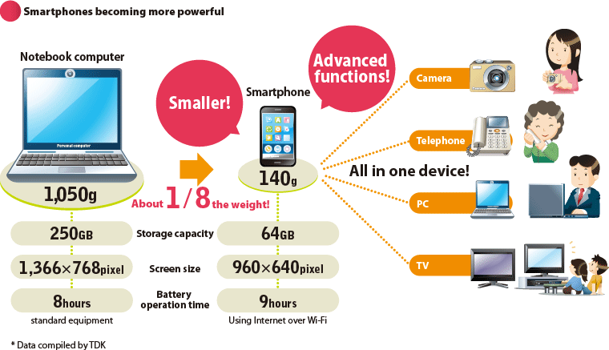

Figure 2.0: Smartphones Becoming More Powerful

Source: [www.global.tdk](http://www.global.tdk) (2012)

The above figure illustrate how smartphones are becoming more powerful day by day with the improvements in the technology field. Some of the common uses of smartphones are GPS to find your way, access your business data at any time, you will be able to conduct last minute researches, schedule keeping, managing the social collaborations and maintaining your schedules.

These trends make clear that these handheld devices and their technologies have become common currency in popular usage. Furthermore, they have penetrated every aspect of human existence. The widespread use of handheld devices in almost all major industries and sectors including financial services is a testimony for the ubiquitous applicability and popularity of mobile technologies.

Susan, a VP in Business Development at Scisbo Business Solutions states some applications of smartphone technologies which can be seen in the society. She mentions that medical doctors are able to monitor patients' health with heartbeat monitors, sleep monitors, and pedometers that connect to the cloud via a smartphone and send an alert when there’s a problem. People with chronic conditions such as diabetes can use a smartphone to monitor their blood sugar, making fewer trips to the clinic.

Furthermore she describes that smartphone docks in cars are valuable for more than just phone calls and entertainment. Now, they can be used for monitoring and diagnostics for the car itself or to track driving patterns for pay-as-you-drive insurance programs. Apart from that she also states that small size business reduce the energy use in commercial buildings by installing intelligent thermostats and heating controllers that can be programmed and monitored with apps and also smartphones can control door locks remotely or even control and monitor a whole security camera network.

It is the latest trend to develop smartphone applications which will communicate with your main server with the aid of a web service. Smartphone apps have been created to solve a problem, increase productivity, offer an intrinsic benefit, or for pure entertainment. Apple's IPhone store alone has more than 150,000 apps available for download and users have downloaded more than 3 billion apps. A custom application for your business can be developed to suit your need with minimum cost.

These results further strengthen the notion that use of handheld devices can greatly enhance the productivity of the business process and the productivity of employees. With the real time access to crucial business statistics, employees are given the opportunity to make informed decisions that greatly contribute to the overall productivity of business operations.

Considering breath of its features, it is clear to the researcher that smartphones have the capacity to be utilized in many areas of work as it is frequently seen that some government institutions and business organizations extensively use web services bases smartphone applications to enhance their customer interaction, productivity of the business and provide a strategic value to their businesses.

2.4 Mobile network penetration and trends of usage of smartphones in Sri Lanka

Accidents can happen anywhere inside this Small Island, it can be a remote location or an urban location. Because of that it is very important study the mobile network penetration inside Sri Lanka. Not only that it is of pivotal importance to study the level of mobile literacy of Sri Lankans to determine whether the insurance filed agents will be comfortable in using such smartphone based solution.

There has being a significant increase in the mobile subscriptions in Sri Lanka over the last decade. It is stated in tradingeconomics (2014) that in the year 2008 up to 95% of population is covered by mobile cellular network in Sri Lanka. The following chart extracted from Trading Economics website illustrate the increase of mobile subscription in Sri Lanka from 2001 to 2013.

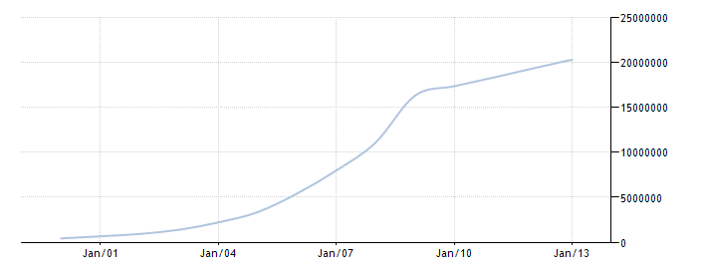

Figure 3.0: increase of mobile subscription in Sri Lanka

Source: Trading Economics (2014)

It is clear that Sri Lanka enjoys a high mobile literacy and considering the statistics of last ten years it is evident that emerging market trends in the mobile usage are seen in Sri Lanka. Apart from that, in Sri Lanka there are approximately over 4 million internet users. According to Nielsen’s “2013 Sri Lanka review” report further emphasizes this trend which highlights 57% of the internet users in Sri Lanka do access internet through a mobile device.

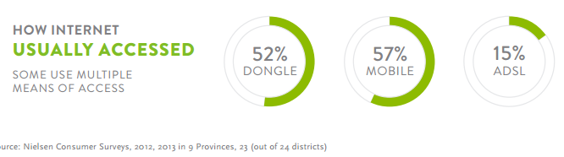

Figure 4.0: How Internet Usually Accessed

Source: Nielsen (2014)

In the present scenario there are five mobile network operators in Sri Lanka namely Dialog, Mobitel, Etisalat, Hutch and Airtel which provides mobile connections to consumers. Dialog offers a wide coverage and undisturbed service whereas Mobitel also have good coverage and specially a good 3G coverage. However if you are not traveling frequently Etisalat or Airtel would be good options. They offer lower call rates. Some youths opt to Hutch as they can easily obtain a connection and easily switch for a new one.

When considering the mobile network coverage available in Sri Lanka, it was obvious to researcher that Sri Lanka enjoys an Island wide mobile coverage encompassing almost 4/5th of the Island. This coverage is facilitated through different network types such as, CDMA, WCDMA, HSDPA, 3G, GSM, and GPRS mostly. Along with that 4G networks are also starting to emerge near major cities. Hence, this tendency to move ahead with latest next generation networks and the breadth of coverage testifies to the existence of positive trends in terms of mobile technological usage. The following figures shows the network coverage of two major service providers.

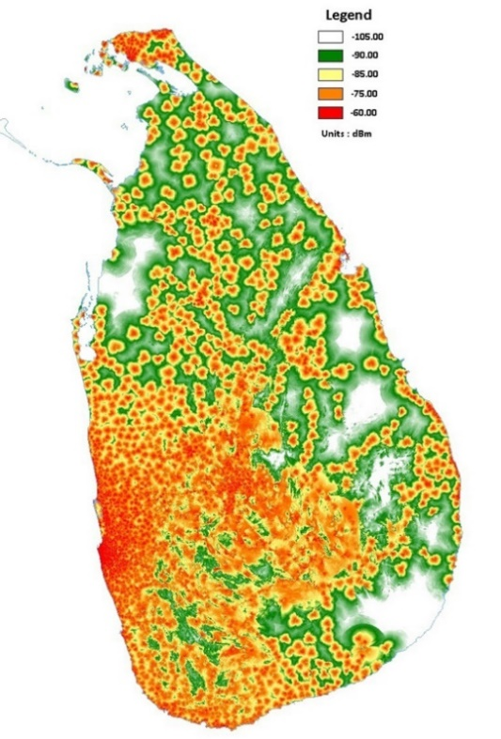

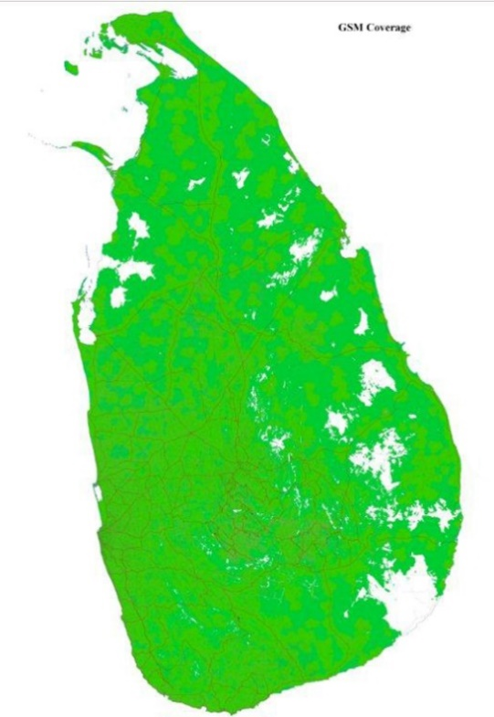

Figure 6.0: Dialog GSM Coverage

Source: Dialog (2014)

Figure 5.0: Mobitel GSM Coverage

Source: Mobitel (2014)

Although mobile and internet usage is widespread in the country it is also important to take a look at the usage of smartphones also. Couple of years back smartphones were not much popular on the market since they were perceived as high end devices which are considered to be expensive also. But now it’s not the case it has become widely affordable and available across the island, you can buy a decent smart phone for a very reasonable price. This results in more people buying smartphones and more people using internet through their device.

By taking into consideration the above facts it is evident that mobile literacy in Sri Lankans is in a healthy condition and all the indications are towards positive growth. Moreover, expanded and expanding nature of mobile network coverage in Sri Lanka shows the emerging trends in mobile technologies and services. Hence, it can be said that Sri Lanka is in the threshold of an adorning mobile era which would facilitates life styles and cooperate habits shaped by mobile technologies which indicates for the researcher that use of mobile technologies in the solution is a timely approach.

2.5 An Overview on Web Services

In the development of the proposed solution web services technologies will be used to connect the main system with the smartphone application. Web services can be identified as application components which communicate using open protocols (XML, SOAP, WSDL and UDDI) over an Internet protocol backbone. Web services are self-contained and self-describing. They can be discovered using UDDI and can be used by other applications (w3schools, 2014). It runs totally without any intelligence or input by a human being. One of the main ideas in developing such systems is that the human involvement is to a minimum and the human error is dealt to a nullity.

When the claiming agent conduct the assessment, the data has to be retrieved and also synchronized with the main database. This happens through the web server. Extensible Markup Language (XML) which is derived from Standard Generalized Markup Language (SGML) is a simple, flexible text format which is used for the development of the web server. There are no pre-defined tags in XML, user has to design their own tags. Document type definitions or XML Schema files are used by XML in order to describe data. XML works as a message carrier in web services.

Following figure demonstrate the overall architecture of a web service

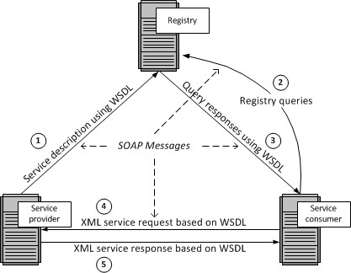

Figure 7.0: Web Services Architecture

Author: Barry DK (n.d)

Service provider host a web service and upload the service description using Web Service Description Language (WSDL) to a registry containing a list of WDL files. WSDL is an XML based language used to describe capabilities and locations of services or in simply how to work with the web service. WSDL uses Simple Object Access Protocol (SOAP) as its communication protocol. SOAP is a framework which support exchange XML based information in a network environment. SOAP is a wrapper class which encapsulates XML based information within HTTP packets in order to send through internet.

Service consumers will search the registry for available web services. Registry is a list of web services from different service providers. It uses the UDDI technology for maintaining the registry. UDDI stands for Universal Description, Discovery and Integration. This provides a platform independent, XML- based registry mechanism between the server and client in order to situate each other. SOAP is used as the communication protocol used by the UDDI.

AS the diagram indicates the once the relevant web service is found, registry will respond with the necessary WSDL files. Using the information in those files service consumer will be able to use the services provided by the provider.

The main advantage of using web services is it allow different applications from different sources to communicate with each other without time-consuming custom coding. Web services do not depend on any one operating system or programming language. They are platform independent because all communication is done using XML. Apart from that using web services help to tighten the security of your data and system since when accessing through a web service, external parties do not have the direct access to companies system or database.

By using the web services in the proposed solution it will enhance the security on cooperate data while providing real time access for the field agents. Apart from that, smartphone solution can be developed on any platform such as Android, Windows or Apple IOS because the smartphone application connect through the web service.

2.6 Examination of Past Research

This section presents past research conducted by academia and industry with regard to use of mobile technologies in claim settlement procedure of motor insurance industry.

In a research conducted by Baecker and Bereuter (2010), they have presented an analysis of claims management processes in motor insurance, and identified several areas for technology-based process improvements. They have categorized the areas such as Mobile loss report, Partner management, Status notification and Customer feedback. In order to establish the technical foundation for identifies areas, they have designed and implemented a service-oriented architecture and has used it to develop a demonstrator, which illustrates the identified process improvements. The demonstrator they have developed incorporates three major components namely Mobile phone application, Service-oriented integration architecture and Claims management enterprise system.

Furthermore they have discussed in the paper about the benefits of a mobile claims assistance application for customers involved in a car accident as well as for insurance companies. In addition, with the aid of demonstrator they have demonstrated that mobile phones are technically capable of reporting claims into commercial claims management enterprise systems.

In 2008, Kaeslin and El Hage conducted a research with the aim of identifying the possible cost reductions for claims management in motor insurance sector. As a result it was observed that the delays in claim settlement can largely be averted by automating the process. In addition to that it states that, it is vital to have proactive contacts between the all the relevant parties throughout the claim settlement process. Kaeslin and El Hage also argues that one of the major challenges that insurance companies have to address in order to improve control over the claims management processes is the lack of adequate IT solutions in the process.

In another research conducted by Lee and colleagues (2007), they have studied about possible strategies and applications for M-commerce in the insurance industry. After conducting a survey among insurance agents in order to explore mobile solutions which are applicable in the business process and to identify the possible benefits for the agents’ tasks, researchers concluded that personal digital assistant (PDA) technology is appropriate for the insurance industry and highlighted the potential for improvements of customer care and claims management.

Although in that era PDA was the popular mobile device which could fit into business solutions, in today’s world smartphone are much more powerful than PDAs and can be much more helpful than PDAs. Since, the entire business world moving towards a virtual market place, the integration of M-strategies with insurance tasks will definitely hold the key for insurance industry in future.

Moreover, IBM (2009) conducted a similar study on process automation in claiming sector. The research investigated the potential effects of automating some steps in a claiming procedure on the quality of customer service. The research concluded that 60% of claiming time can be reduced by the automation which eliminated “low- to no-touch management” in several phases.

It is stated by Want (2009) that while the applications such as eCall are currently deployed in motor vehicles, similar applications will become available for mobile phones as their computational power increases, additional sensor technology becomes available, and the necessity to integrate mobile phones with enterprise wide systems will rise.

As the above researches indicates the interest of academics of the possibilities of integrating smartphone technologies to enhance claim management processes and shows the necessity for further research in this area considering the competitive nature of the motor insurance industry which demands the integration of such mobile technologies.

2.7 Summary

This chapter was dedicated to conduct a survey regarding to problem domain, technologies available for the solution and also to examine past researched conducted on the similar area of research. As the first step it is discussed about the motor vehicle insurance industry niche of insurance sector. It was pointed out that better coordination and management of claiming process will lead to gaining more profits.

Next it is reflected an overview about the smartphones in this era of mobility and smart devices. It is briefly explained about what is a smartphone device and about the powerful hardware and software combination that smartphones are made up of. Along with that as the next step mobile network penetration and smartphone usage in Sri Lanka is examined. Since the smartphone prices are gradually decreasing but with day by day advancements in the devices, people have showed positive responses to the use of smartphones. Mobile networks in Sri Lanka also covers large areas around all most all the major cities and day by day it is growing with new technologies such as 4G. By considering networks and smartphone technologies it can be deduced that in the present smartphone based approach for the solution is the most suitable option.

As the proposed solution includes web technologies, in the chapter it is also discussed about web services and other related components such as WSDL, UDDI and SOAP. By using the web services in the proposed solution it will enhance the security on cooperate data while providing real time access for the field agents. Apart from that, smartphone solution can be developed on any platform such as Android, Windows or Apple IOS because the smartphone application connect through the web service.

Finally this chapter presents an evaluation on past researches conducted by professional on the subject of use of mobile technologies in the motor vehicle insurance sector. It show that there is a great potential towards research for mobile integrated solution for insurance companies as well as for the clients also.

References

Baecker, O., & Bereuter, A. (2010), *Technology-Based Industrialization of Claims Management in Motor Insurance,* Institute of Technology Management, University of St. Gallen.

Retrieved September 10th 2014, from the University of St. Gallen i-lab website: <http://www.i-lab.ch/docs/04_technology> based_industrialization_of_claims_management_in_motor_insurance.pdf

Baecker O., Fleisch E., Ackermann W., Ackermann L 2010, Mobile Claims Management: Smartphone Apps in Motor Insurance, Trendmonitor 4 . 2010

Barry D., K. n.d*, Web Services Explained,* Viewed 9th December 2014

<http://www.service-architecture.com/articles/web-services/web_services_explained.html>

Capegemini 2013, Mobile Solutions for Claims Management, Viewed 10th October 2014

http://www.capgemini.com/resource-file-access/resource/pdf/mobile_solutions_for_claims_management_0.pdf.

Dialog Axiata 2014, *Coverage Map,* Viewed 26th November 2014

<http://www.dialog.lk/support/mobile/coverage-service-points/coverage-map/>

Flitch Ratings 2013, *2014 Outlook: Sri Lanka Insurance Sector,* Outlook Report.

Retrieved September 17th 2014 from [www.fitchratings.lk/download-article-216.pdf](http://www.fitchratings.lk/download-article-216.pdf)

‘Gartner’ 2014, *Gartner Says Annual Smartphone Sales Surpassed Sales of Feature Phones for the First Time in 2013,* Viewed 29th October 2014

<http://www.gartner.com/newsroom/id/2665715>

IBM 2009, Fast path claims from IBM. Viewed 10th October 2014

http://www-03.ibm.com/industries/financialservices/doc/content/solution/1231013103.html.

Iqbal I. 2014*, Rapid Growth of Mobile Internet Usage in Sri Lanka,* Viewed 25th November 2014

<http://infasiqbal.com/rapid-growth-of-mobile-internet-usage-in-sri-lanka/>

Lee C, Cheng H., K., Cheng H. 2007, an empirical study of mobile commerce in insurance industry: Task-technology fit and individual differences, Decision Support Systems.

Mobitel 2104, *Mobitel GSM and 3G Coverage,* Viewed 26th November 2014

<http://www.mobitel.lk/images/English/common/Srilanka_GSM_Coverage%2030112013.jpg>

Nielsen 2013, Sri Lanka 2013 review and opportunities in 2014, Viewed 10th October 2014

http://www.nielsen.com/lk/en/insights/reports/2014/sri-lanka-2013-in-review-and-opportunities-in-2014.html

Susan W. 2013, Widespread *Adoption of Tablets and Smartphones Is Driving Growth in the Internet of Things,* Viewed 29th October 2014

<https://www.scisbo.com/web/business-solutions/blog/-/blogs/widespread-adoption-of-tablets-and-smartphones-is-driving-growth-in-the-internet-of-things>

TDK Global 2012*, Devising Total Solution for Condensing a Multitude of Function within a Limited Space,* Viewed 29th October 2014

<http://www.global.tdk.com/ir/ir_library/annual/2012/html/strategy/str01.htm>

Trading Economics 2014, *Mobile cellular subscriptions in Sri Lanka*, Viewed 29th November 2014

<http://www.tradingeconomics.com/sri-lanka/mobile-cellular-subscriptions-wb-data.html>

w3schools 2104, *Introduction to Web Services*, Viewed 9th December 2014

<http://www.w3schools.com/webservices/ws_intro.asp>

Want R 2009, When Cell Phones Become Computers, IEEE Pervasive Computing.